Article ID: 1164
Article Name: The clothes are much to wrinkled after washing in washer dryer
Topic Location: Laundry / washing machine / usage / performance
Meta-data: wrinkles, creases,
Related Articles:
Related Questions:
PNC
DIY
Safety
Link
Email
Book Engineer
Multimedia
Brand
Article Content:

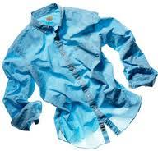  1164_01_WD_Clothes are much too wrinkled after washing_JAT-13-12-03 | There could be three main causes for this:  - Overloaded. Make sure the drum isn’t overloaded with clothes. Check the user manual for instruction on load and type of fabrics.  - Inadequate spinning speed. You should choose the correct spinning speed for the type of clothes and load you are going to wash. Always check the user manual.  - Water temperature too hot. Also check that the selected water temperature is adequate for the type of laundry in the drum.
  1164_02_WD_Clothes are much too wrinkled after washing_JAT-13-12-03 | Hint! Make sure that affected laundry is taken out of the drum as soon as they have spun because laying in the drum for lengthy periods can also cause creasing

